PERSONAL INFORMATION | Vincenzo Iannuzzi
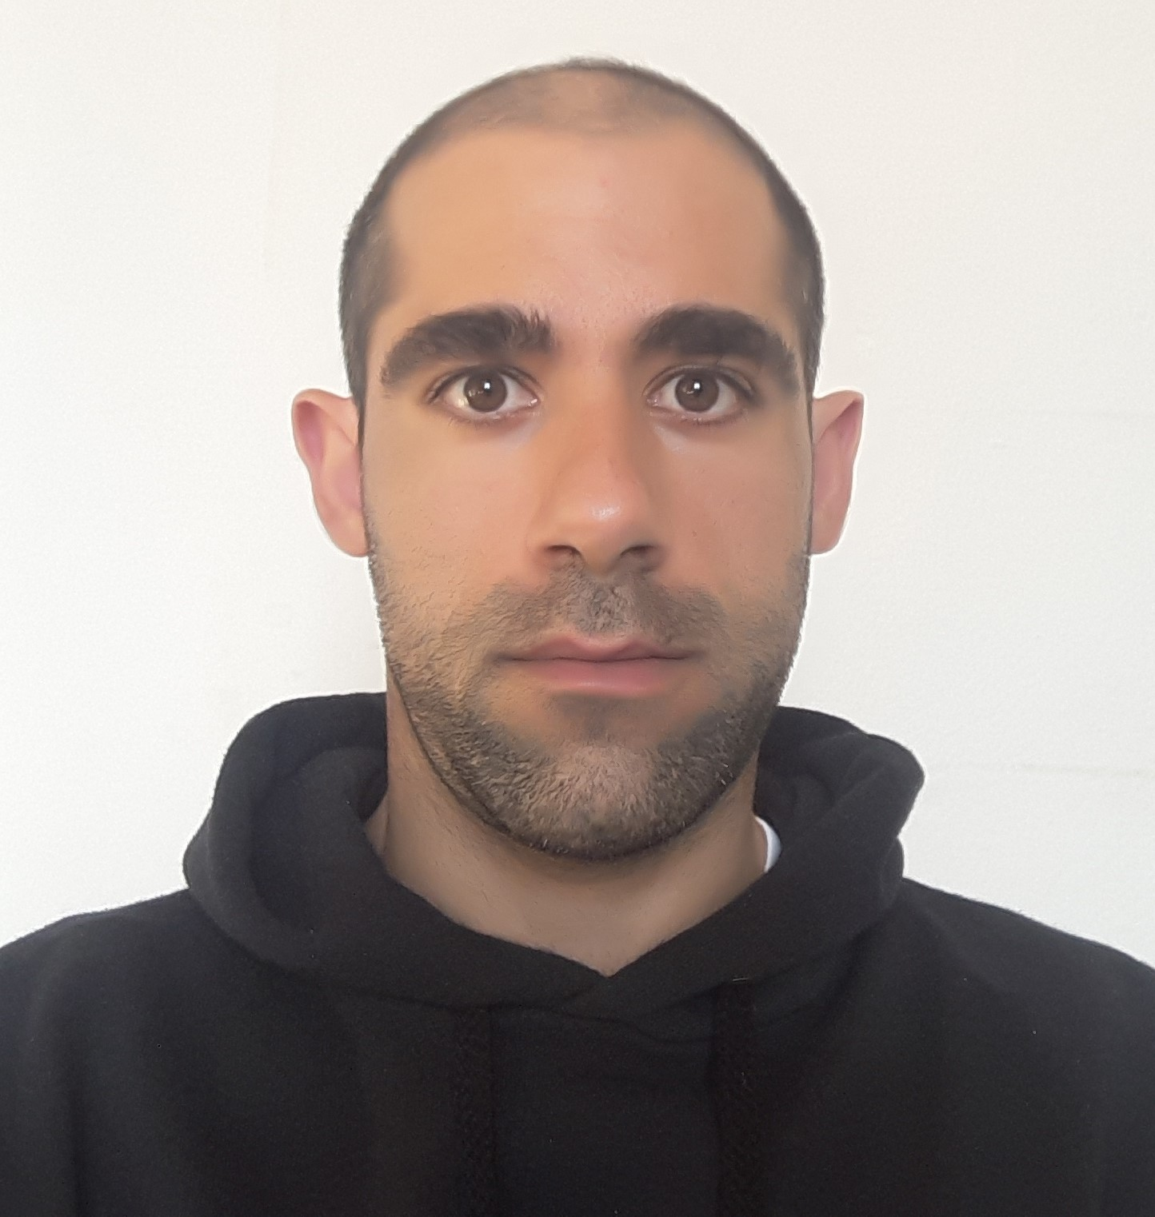 |  Via San Martino, 5, 84040, Roccagloriosa (SA) - Frazione Acquavena, Italy
 |  +390974980221  +393402528961
 |  vincenzo.iannuzzi2@unibo.it; iannuzzivinc94@gmail.com
 | Sex Male | Date of birth 21/04/1994 | Nationality Italian

EDUCATION AND TRAINING

01-11-2021-ONGOING | PhD in Earth, Life and Environmental Sciences (STVA)
01-11-2021-ONGOING | Laboratory of Molecular Anthropology, University of Bologna, Via Francesco Selmi 3, 40126, Bologna (BO)
01-11-2021-ONGOING | - Research project title: Evolutionary, ecological and biodemographic analysis of human lifespan  - Principal subjects covered: Human Lifespan, Population Epigenetics, Molecular Anthropology, DNA methylation Variability, Human Environment Interactions, Human Adaptations

03/2020-09/2021 | Scholarship
03/2020-09/2021 | Interdepartmental Centre Alma Mater Research Institute on Global Challenges and Climate Change (Alma Climate), University of Bologna, Via Giuseppe Petroni 26, 40126 Bologna
03/2020-09/2021 | - Main Research Theme: Genetic adaptation and acclimatization at high altitudes as experimental models for the study of physiological response mechanisms to hypoxia (SHERPA 2020 project)

12/03/2021-26/03/2021 | Participation Certificate at Machine Learning Seminars
12/03/2021-26/03/2021 | Department of Management, University of Bologna, Via Capo di Lucca 34, 40126, Bologna (BO)
12/03/2021-26/03/2021 | - Attended Seminars:  Seminar 1  Friday, March 12  Artificial Intelligence e Machine Learning on Supervised Learning  Speaker: Jason Anastasopoulos (Institute for Artificial Intelligence - Università of Georgia, USA)  Principal subjects covered: Introduction to natural language processing  Seminar 2:  Friday, March 26  Introduction to Supervised Learning  Speaker: Jason Anastasopoulos (Institute for Artificial Intelligence - Università of Georgia, USA)  Principal subjects covered: Pre-processing text data (tokenization, stemming, removing stop words), Naïve Bayes algorithm
05/02/2021-12/02/2021 | Participation Certificate at Python Seminars
05/02/2021-12/02/2021 | Department of Management, University of Bologna, Via Capo di Lucca 34, 40126, Bologna (BO)
05/02/2021-12/02/2021 | - Attended Seminars:  Seminar 1  Friday, February 5  Data visualization in Python  Speaker: Jason Anastasopoulos (Institute for Artificial Intelligence - Università of Georgia, USA)  Principal subjects covered: Data visualization in Pandas, Basic Plot (Line plots, Scatterplots, Heatmaps), Density Plot, Box Plot, Histograms, Plots with Seaborn, Geospatial Data Visualization  Seminar 2:  Friday, February 12  Databases and Advanced Webscraping  Speaker: Jason Anastasopoulos (Institute for Artificial Intelligence - Università of Georgia, USA)  Principal subjects covered: Web Scraping Data from the Internet with APIs, Storing and Retrieving Data with Databases

09/02/2021-25/02/2021 | Participation Certificate at the 22nd Bologna Winter School on Bioinformatics - BIOINFORMATICS FOR DISCOVERY IN STRUCTURAL AND FUNCTIONAL BIOLOGY
09/02/2021-25/02/2021 | Department of Pharmacy and Biotechnology, University of Bologna, Via Belmeloro 6, 40126, Bologna (BO)
09/02/2021-25/02/2021 | - Attended Seminars:  Seminar 1  Tuesday, February 9  Disease trajectories at the medical and molecular levels.  Speaker: Alfonso Valencia (Life Science Department, Barcelona Supercomputing Center, ES)  Seminar 2  Thursday, February 11  Bringing structure to (protein) disorder: understanding a biological phenomenon  Speaker: Silvio Tosatto (Department of Biomedical Sciences, University of Padova, IT)  Seminar 3:  Monday, February 15  AI and protein structure prediction  Speaker: David Jones (Department of Computer Science, UCL and Francis Crick Institute, UK)  Seminar 4:  Tuesday, February 16  RNA secondary structure for functional annotation  Speaker: Manuela Helmer-Citterich (Department of Biology, University "Tor Vergata", Rome, IT)  Seminar 5:  Wednesday, February 17  Bioinformatics for transcriptomics  Speaker: Roderic Guigò (Bioinformatics and Genomics, Center for Genomic Regulation, ES)  Seminar 6:  Thursday, February 18  Epigenomics and development  Speaker: Montserrat Corominas (Department of Genetics, University of Barcelona, ES)  Seminar 7:  Thursday, February 18  Comparative and evolutionary genomics of SARS-Cov-2: Data, Resources and Open Science  Speaker: Graziano Pesole (IBIOM, National Research Council, Bari, IT)  Seminar 8:  Friday, February 19  Challenges and opportunities for ultra-large scale multiple sequence alignment modelling  Speaker: Cedric Notredame (Bioinformatics and Genomics, Center for Genomic Regulation, ES)  Seminar 9:  Thursday, February 25  Insights on key molecular mechanisms of synaptic transmission from computer simulation  Speaker: Paolo Carloni (Institute for Advanced Simulation, Jülich Research Center, DE)

09/2018-02/2019 | Internship for the preparation of the final master degree thesis
09/2018-02/2019 | Laboratory of Molecular Anthropology, University of Bologna, Via Francesco Selmi 3, 40126, Bologna (BO)
09/2018-02/2019 | - Principal subjects covered: methylation data analysis using existing pipelines, creation of a new pipeline for the integration of genomic and epigenomic data, statistical analysis of genomic variability among human groups, gene enrichment analysis, ancient and recent selective pressure tests, identification of genomic variants related to epigenetic plasticity

01/2017-07/2019 | Master Degree in Statistical Sciences
01/2017-07/2019 | University of Bologna, Via Zamboni 33, 40126, Bologna (BO)
01/2017-07/2019 | - Principal subjects covered: Advanced models for the Survival Analysis, Qualitative Data analysis, Statistical models for biological and social sciences, Computational Human Genomics, Human Genetics  - Thesis: Integrating -omic data in evolutionary studies. Statistical methods for detecting phenotypic plasticity in human groups  - Mark: 110/110 cum Laude

09/2013-07/2016 | Bachelor Degree in Statistical Sciences
09/2013-07/2016 | University of Bologna, Via Zamboni 33, 40126, Bologna (BO)
09/2013-07/2016 | - Principal subjects covered: Statistics, Mathematics, Informatics, Probability, Linear Models, Analysis of Time Series  - Thesis: Handling Missing Data in Analysis of Time Series  - Final Mark: 110/110 cum Laude

09/2008-07/2013 | High School Diploma
09/2008-07/2013 | High School I.I.S Carlo Pisacane, Via Gaetani 5, 84073, Sapri (SA)
09/2008-07/2013 | - Principal subjects covered: Mathematics, Physics, Biology, Chemistry, English, Astronomy  - Final Mark: 97/100

CERTIFICATIONS

9/11/2011-9/12/2011 | English Certification (Trinity College)
9/11/2011-9/12/2011 | Trinity College London Cert TESOL - University of Wolverhampton, Telford Innovation Campus, Telford (UK)
9/11/2011-9/12/2011 | - Spoken English  - Final Mark: B2

10/2015-06/2016 | English Certification (IELTS)
10/2015-06/2016 | CLA - Centro Linguistico di Ateneo of University of Bologna, AlmaEnglish Project, Piazza S. Giovanni in Monte 4, 40124 Bologna (BO)
10/2015-06/2016 | - 100 hours of English Course (Listening, Reading, Spoken Language)  - Final Mark: B2

PERSONAL SKILLS

Mother tongue(s) | Italian
Other language(s) | UNDERSTANDING |  |  |  | SPEAKING |  |  |  | WRITING
Other language(s) | Listening |  | Reading |  | Spoken interaction |  | Spoken production
English | B2 |  | B2 |  | B2 |  | B2 |  | B2
 | IELTS certificate
French | B1 | B1 |  | B1 |  | B1 |  | A2
Levels: A1/2: Basic user - B1/2: Independent user - C1/2 Proficient user
Common European Framework of Reference for Languages

Communication skills | ▪ Speaking in public and to groups  - Excellent written and verbal communication skills

Organisational skills | - Excellent propensity for team working gained during the internship at the Laboratory of Molecular Anthropology  - I deliver on my promises and complete anything I start

Job-related skills | - Flexible to different working contexts  - Work ethic  - Cooperative and enthusiastic character

Computer skills | - Good command of office suite (word processor, spread sheet, presentation software)  - Excellent command of R software  - Good command of Python Software  - Excellent command of Linux and Windows OSs

Other skills | - Stress management  - Problem solving  - Emotional intelligence

ADDITIONAL INFORMATION

Publications | I am author of 10 publications on peer-reviewed journals  - Belcastro M.G., Mariotti V., Pietrobelli A., Rastelli E., Iannuzzi V., Toselli S. Variations in epiphyseal fusion and persistence of the epiphyseal line in the appendicular skeleton of two identified modern (19th–20th c.) adult Portuguese and Italian samples, American Journal of Physical Anthropology 169, 3. https://doi.org/10.1002/ajpa.23839  - Francesco Campa, Analiza Silva, Vincenzo Iannuzzi, Gabriele Mascherini, Luca Benedetti, Stefania Toselli. The Role of Somatic Maturation on Bioimpedance Patterns and Body Composition in Male Elite Youth Soccer Players, International Journal of Environmental Research and Public Health, 2019 Dec; 16(23): 4711. doi: 10.3390/ijerph16234711  - Kalyakulina A, Iannuzzi V, Sazzini M, Garagnani P, Jalan S, Franceschi C, Ivanchenko M, Giuliani C. Investigating Mitonuclear Genetic Interactions Through Machine Learning: A Case Study on Cold Adaptation Genes in Human Populations From Different European Climate Regions. Front Physiol. 2020 Nov 11;11:575968. https://doi.org/10.3389/fphys.2020.575968. PMID: 33262703; PMCID: PMC7686538.  - Grigoletto A, Mauro M, Maietta Latessa P, Iannuzzi V, Gori D, Campa F, Greco G, Toselli S. Impact of Different Types of Physical Activity in Green Urban Space on Adult Health and Behaviors: A Systematic Review. European Journal of Investigation in Health, Psychology and Education. 2021; 11(1):263-275. https://doi.org/10.3390/ejihpe11010020  - Garagnani P, Marquis J, Delledonne M, Pirazzini C, Marasco E, Kwiatkowska KM, Iannuzzi V, Bacalini MG, Valsesia A, Carayol J, Raymond F, Ferrarini A, Xumerle L, Collino S, Mari D, Arosio B, Casati M, Ferri E, Monti D, Nacmias B, Sorbi S, Luiselli D, Pettener D, Castellani G, Sala C, Passarino G, De Rango F, D'Aquila P, Bertamini L, Martinelli N, Girelli D, Olivieri O, Giuliani C, Descombes P, Franceschi C. Whole-genome sequencing analysis of semi-supercentenarians. Elife. 2021 May 4;10:e57849. doi: 10.7554/eLife.57849. PMID: 33941312.  - Levi, G., de Lombares, C., Giuliani, C., Iannuzzi, V., Aouci, R., Garagnani, P., Franceschi, C., Grimaud-Hervé, D., & Narboux-Nême, N. (2021). DLX5/6 GABAergic Expression Affects Social Vocalization: Implications for Human Evolution. Molecular biology and evolution, 38(11), 4748–4764. https://doi.org/10.1093/molbev/msab181  - Conte, M., Giuliani, C., Chiariello, A., Iannuzzi, V., Franceschi, C., & Salvioli, S. (2022). GDF15, an emerging key player in human aging. Ageing research reviews, 75, 101569. https://doi.org/10.1016/j.arr.2022.101569  - Iannuzzi, V., Bacalini, M.G., Franceschi, C., Giuliani C. The role of genetics and epigenetics in sex differences in human survival. Genus 79, 1 (2023). https://doi.org/10.1186/s41118-023-00181-1  - De Giovanni A, Iannuzzi V, Gallello G, Giuliani C, Marini M, Cervera ML, Luiselli D. Mercury Intake Estimation in Adult Individuals from Trieste, Italy: Hair Mercury Assessment and Validation of a Newly Developed Food Frequency Questionnaire. Pollutants. 2023; 3(3):320-336. https://doi.org/10.3390/pollutants3030022  - Iannuzzi V, Sarno S, Sazzini M, Abondio P, Sala C, Bacalini MG, Gentilini D, Calzari L, Masciotta F, Garagnani P, Castellani G, Moretti E, Dasso MC, Sevini F, Franceschi ZA, Franceschi C, Pettener D, Luiselli D, Giuliani C. Epigenetic aging differences between Wichí and Criollos from Argentina: Insights from genomic history and ecology. Evol Med Public Health. 2023 Oct 16;11(1):397-414. doi: 10.1093/emph/eoad034. PMID: 37954982; PMCID: PMC10632719.

Posters | - XXIII AAI (Associazione Antropologica Italiana) Conference:  Padova, 4-6 September 2019  Giulia Solazzo, Maria Filippini, Stefania Sarno, Elena Marasco, Sara De Fanti¹, Paolo Garagnani, Maddalena Milazzo, Claudio Franceschi, Chiara Pirazzini, Maria Giulia Bacalini, Vincenzo Iannuzzi, Alessio Boattini, Alessandro Gargini, Donata Luiselli, Cristina Giuliani, The role of epigenetics in human adaptation: preliminary data on the geographic correlation between DNA methylation levels and groundwater pesticides distribution in Italy  - Wellcome Connecting Science Conference:  Healthy Ageing 2022 virtual conference, 25-27 May 2022  Vincenzo Iannuzzi, Paolo Garagnani, Claudio Franceschi, Cristina Giuliani. Whole-genome sequence analysis of Italian semi-supercentenarians. Lightning talk youtube link: https://www.youtube.com/embed/xtFr3cnEGlA.  - XXIV AAI (Associazione Antropologica Italiana) Conference:  Chieti, 7-10 September 2022  Bolognesi G., Iannuzzi V., Gargini A., De Sanctis A., Luiselli D., Sarno S., Marasco E., Garagnani P., Filippini M., Giuliani C. The effect of chlorinated solvents on human DNA methylation variability. Awarded as best poster in the molecular anthropology section.  - XXV AAI (Associazione Antropologica Italiana) Conference:  Torino, 6-8 September 2023  Vincenzo Iannuzzi, Maria Giulia Bacalini, Stefania Sarno, Maria Filippini, Elena Marasco, Donata Luiselli, Chiara Pirazzini, Claudio Franceschi, Giuseppe Passarino, Paolo Garagnani, Stanley Ulijaszek, Cristina Giuliani. Degree of urbanization and human epigenetic variability: a case study on DNA methylation in the Italian population. Awarded as best poster in the molecular anthropology section.  - XXV AAI (Associazione Antropologica Italiana) Conference:  Torino, 6-8 September 2023  Stefania Sarno, Vincenzo Iannuzzi, Marco Sazzini, Paolo Abondio, Claudia Sala, Maria Giulia Bacalini, Davide Gentilini, Luciano Calzari, Federica Masciotta, Paolo Garagnani, Gastone Castellani, Edgardo Moretti, Maria Cristina Dasso, Federica Sevini, Zelda Alice Franceschi, Claudio Franceschi, Davide Pettener, Donata Luiselli, Cristina Giuliani. Exploring the impact of human evolutionary history on epigenetic clocks:  the case study of Wichí and Criollos in Argentina  - General Meeting Age-IT: Ageing Well in an Ageing Society  Venezia, 20-22 Maggio 2024  Cristina Giuliani, Vincenzo Iannuzzi, Stefania Sarno. Epigenetic aging in Wichí and Criollos from Argentina: an evolutionary ecology perspective

Oral Communications | - Genome Evolution: New Frontiers and Challenges  Online conference event, 9 October 2020  Vincenzo Iannuzzi, Maria Giulia Bacalini, Stefania Sarno, Maria Filippini, Elena Marasco, Chiara Pirazzini, Claudio Franceschi, Giuseppe Passarino, Paolo Garagnani, Cristina Giuliani. Degree of urbanization and human epigenetic variability: a case study on DNA methylation in the Italian population  - 94° Congresso SIBS - Società Italiana di Biologia Sperimentale  Torino, 6 - 9 aprile 2022  Katarzyna M. KWIATKOWSKA, Vincenzo IANNUZZI, Chiara PIRAZZINI, Daniela MONTI, Claudio FRANCESCHI, Giuseppe PASSARINO, Giorgia GIROTTO, Maria Pina CONCAS, Paolo GASPARINI, Paolo GARAGNANI, Cristina GIULIANI. Genetic determinants of sensory impairment in italian semi-supercentenarians.  - XXIV AAI (Associazione Antropologica Italiana) Conference:  Chieti, 7-10 September 2022  Vincenzo Iannuzzi, Giovanni Levi, Nicolas Narboux-Nême, Claudio Franceschi, Paolo Garagnani, Cristina Giuliani. Insights into the role of an archaic haplotype located in DLX5/6 gene locus in human longevity.  - XXV AAI (Associazione Antropologica Italiana) Conference:  Torino, 6-8 September 2023  Bolognesi G., Iannuzzi V., Sarno S., De Sanctis A., Bacalini M.G., Ravaioli F., De Fanti S., Gargini A., Luiselli D., Marasco E., Garagnani P., Filippini M., Giuliani C. Environmental contaminants and human DNA methylation variability  - General Meeting Age-IT: Ageing Well in an Ageing Society  Venezia, 20-22 Maggio 2024  Vincenzo Iannuzzi, Cristina Giuliani. Degree of urbanization at birth and epigenetic variability: a case study on DNA methylation in the Italian population

Research Projects | I was actively involved in the following research projects:  - Interazione uomo-ambiente: contaminazione da SOlventi Clorurati e Impatto sui profili Epigenetici (metilazione del DNA) nella popolazione ITaliana [SOCIE-IT] – Progetto finanziato da Università di Bologna (ALMAIDEA 2017 a dott.ssa Cristina Giuliani)  - Progetto di Ricerca di Rilevante Interesse Nazionale (PRIN) entitled “Sensory decays and aging” (PI prof. Paolo Gasparini, Università degli Studi di Trieste)  I am currently involved in the following research projects:  - Partenariato Esteso 8 (PE8) - Project Age-It: ‘Ageing Well in an Ageing Society’  - Progetto di Ricerca di Rilevante Interesse Nazionale (PRIN) entitled “SHOVELING into the North Italian Bronze Age with an integrative approach to unearth the evolutionary origins of a non-metric dental trait” (PI prof. Barbara Bramanti, Università degli Studi di Ferrara)

Visiting | I was a visiting PhD student at the following laboratories:  - Museum National D’histoire Naturelle (MNHN) of Paris (UMR7221 Molecular Physiology & Adaptation) from 15/09/2023 to 15/12/2023 and from 01/06/2024 to 30/06/2024 within the theme of the research project entitled “The genetics of ageing and sociality across human evolution”, under the supervision of Dr. Nicolas Narboux-Nême  - Conservatoire National Des Arts Et Métiers (CNAM) of Paris (Laboratoire Génomique, Bioinformatique, et Applications (GBA, EA4627)) from 01/05/2024 to 31/05/2024 within the theme of the research project entitled “Etude genomique et transcriptomique comparant les patients atteints de séquelles au long cours notamment inflammatoires de l’infection Chikungunya et les patients infectés sans symptômes au long cours”, under the supervision of Prof. Jean-François Zagury.

Award | I was awarded the following prizes:  - Bourses du Governament Français 2023 (BGF2023) with the project entitled: “The genetics of ageing and sociality across human evolution”.  - ISA Doctoral Prize 2023 (University of Bologna) with the project entitled: “Investigating biological and non-biological determinants of human longevity: an integrated approach at the interface between molecular anthropology and ecology”

Co-supervisor of Bachelor and Master Degree Thesis | Federica La Rocca, Master Degree in Biodiversity and Evolution, 2021  Marika Taroni, Master Degree in Health Biology, 2022  Anita Martini, Bachelor Degree in Statistical Sciences, 2022  Sara Piazzi, Master Degree in Biodiversity and Evolution, 2023  Elisa Zucco, Bachelor Degree in Biological Sciences, 2024

Il sottoscritto, a conoscenza che ai sensi dell’art. 26 della Legge 15/68 le dichiarazioni mendaci, la falsità negli atti e l’uso di atti falsi sono puniti ai sensi del codice penale e delle leggi speciali e consapevole delle sanzioni penali richiamate dall'art. 76 del D.P.R 28/12/00 n° 445 in caso di dichiarazioni mendaci e della decadenza dei benefici eventualmente conseguenti al provvedimento emanato sulla base di dichiarazioni non veritiere, di cui all'art. 75 del D.P.R. del 28/12/00 n° 445, ai sensi e per gli effetti degli artt. 46 e 47 del citato D.P.R. 445/2000, sotto la propria responsabilità dichiara che quanto riportato nel presente CV corrisponde al vero.

Dichiaro quindi di possedere ogni titolo riportato nel presente curriculum.

Inoltre, il sottoscritto autorizza al trattamento dei dati personali, secondo quanto previsto dal D.L. 30 Giugno 2003 n° 196 “Codice in materia di protezione dei dati personali” al solo scopo di trattare, inserire e conservare nella Vs. banca dati tutti i dati contenuti nel presente.

Bologna, 08/07/2024

