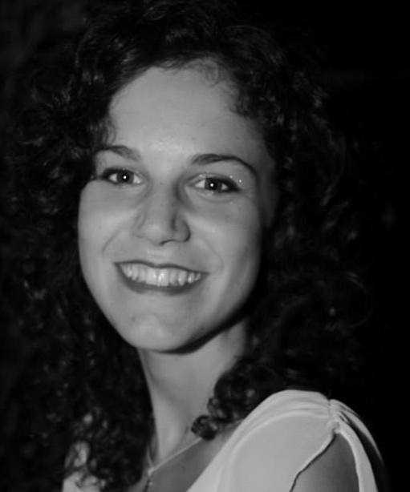
EDUCATION
Alma Mater Studiorum – University of Bologna, Italy
10/2019 – 05/2022 (extraordinary covid session)
Two years master’s degree in Biodiversity and Evolution, final grade: 110/110.
Title thesis: Study of the relationship between physiological responses, functional traits and abiotic stresses in lichens.

Alma Mater Studiorum – University of Bologna, Italy
09/2016 – 12/2018
Bachelor in Biology, final grade: 103/110.
Title thesis: Identification of primers for the amplification of intersatellite fragments in Puccinellia fasciculata (torr.) e. p. bicknell.

Liceo scientifico Rambaldi-Valeriani – Imola (BO), Italy
2011 – 2015
High school diploma in scientific field, final grade: 85/100

Imola, Italy
+39 3318079345

castellariveronica@gmail.com

- Agroforestry and horticultural activities
- Landscaping and environmental management activities
- Food recovery and redistribution
Environmental community service - Bologna, Italy
14/11/2022- 30/04/2023

- Project “Ecosystem for Sustainable Transition in Emilia-Romagna (ECOSISTER)” - Materials for sustainability and ecological transition
- Activities : extraction analysis of polyphenols and sugars from artichoke plants
- Instruments : spectrophotometer, HPLC
01/05/2023 – 30/04/2024
Reasearch fellow – University of Bologna, Italy
PROFESSIONAL EXPERIENCES
Trainee – University of Bologna, Italy
09/2021 – 12/2021
DIGITAL SKILLS

THECNICAL SKILLS
- PCR, electrophoresis, fluorometer, thermographic camera, GenAlex 6.5, past 3.20, R, spectrophotometer, HPLC.

- Activities: contribution to the lichenological herbarium digitizing the various species samples

- Office
Reasearch and development in projects to restore biodiversity.
PROFESSIONAL GOALS
Veronica Castellari
©AZURIUS – Modeles-de-cv,com
Trainee – Faculdade de Ciencias de Lisboa, Portugal

04/2021 – 06/2021
- Erasmus+ traineeship performing my experience in Lisbon
- Instruments : fluorometer and the thermographic camera
- Goals software : R
- Activities : study the different dark adaptation times and water content on 7 lichens species.

Trainee – University of Bologna, Italy

2017 – 2018
- Activities : identification of primers for the amplification of intersatellite fragments in Puccinellia fasciculata (torr.) e. p. bicknell
- Goals software: GenAlex 6.5 and past 3.20
- Instruments: PCRs and electrophoresis

Accademic project – University of Bologna, Italy
07/2019

“Sea sentinals project” started by Professor Stefano Goffredo (Sentinelle del Mare - DUEproject, http://dueproject.org/en/research/).
Activities: involve people to record the presence and abundance of key Mediterranean species, increase environmental knowledge and awareness.
I spent two weeks for the project: one week in Bordighera (Liguria), the other one in Ventimiglia (Liguria).

EXTRACURRICULAR ACTIVITIES

SUMMER SCHOOL – Bologna, Italy
One intensive week in July, 2023. Despite lot of candiates, I won the possibility to participate at the the BIO-PLASTICS EUROPE project, called The New Plastics Economy: Circular Business Models and Sustainability, based on frontal lectures, site visits, team working, workshop, (https://site.unibo.it/the-new-plastics-economy-circular-business-models-and-sustainability/en).

WORKAWAY PERMACULTURE PROJECT - Denmark
2 weeks at Orø (In Holbæk), in July 2022.

VOLUNTEER IN CASENTINO FOREST PARK – Arezzo, Italy
1 week of volunteering in the Foresente Casentinesi National Park where I came into contact with a PhD doctor who included us in part of her field research project, in April 2019 (https://www.parcoforestecasentinesi.it/it/vivi-il-parco/attivita/volontariato-nel-parco).

ONLINE TRAINING - University of Padova, Italy
course based on identification and recognition the hill and mountain butterflies species of the Eastern Alps Italy.

AWARDS
- “Premio Poster” won during the conference of the Italian Lichenological Society in 2021.

- Schoolarship won during the conference of the Italian Lichenological Society in 2022 (https://convegnoslipavia.altervista.org/premi-awards/).

PUBBLICATIONS
BOOK OF ABSTRACTS
Castellari V., Nascimbene J., Munzi S., Più a lungo è meglio? Impatto della durata del tempo di adattamento al buio sulle misure di fluorescenza in talli lichenici, in: Notiziario della Società Lichenologica Italiana,2021, 34, pp. 35, http://www.lichenologia.eu/pdeffi/Notiziario_2021.pdf .

SCIENTIFIC DISSEMINATION
Castellari V., Munzi S. - Licheni epifiti, adattamento al buio e contenuto idrico… in Portogallo! in: Notiziario della Società Lichenologica Italiana, 2021, vol. 34, pp. 67-72, ISSN 1121- 9165

CERTIFICATES
Open Water Diver (first level diving license), Advanced Open Water (second level diving license).
This is an Open Badge that was issued to certify my skills. Click on the image to go to the details of my training experience.
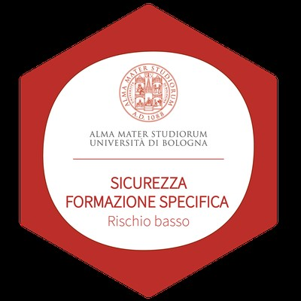

HOBBIES
Sport activities: volleyball (10 years, agonistic level), beach volley (2 years), hiking, climbing, football, swimming.

LANGUAGES
English: B2-C1 level
French: A2 level
Spanish: A2 level

I authorize the processing of my personal data present in the curriculum vitae pursuant to Legislative Decree 30 June 2003, n. 196 and of the GDPR (EU Regulation 2016/679).

DATE 20/02/2024 SIGNATURE Veronica Castellari

