Curriculum vitae – Federica Zanetti

PERSONAL INFORMATION
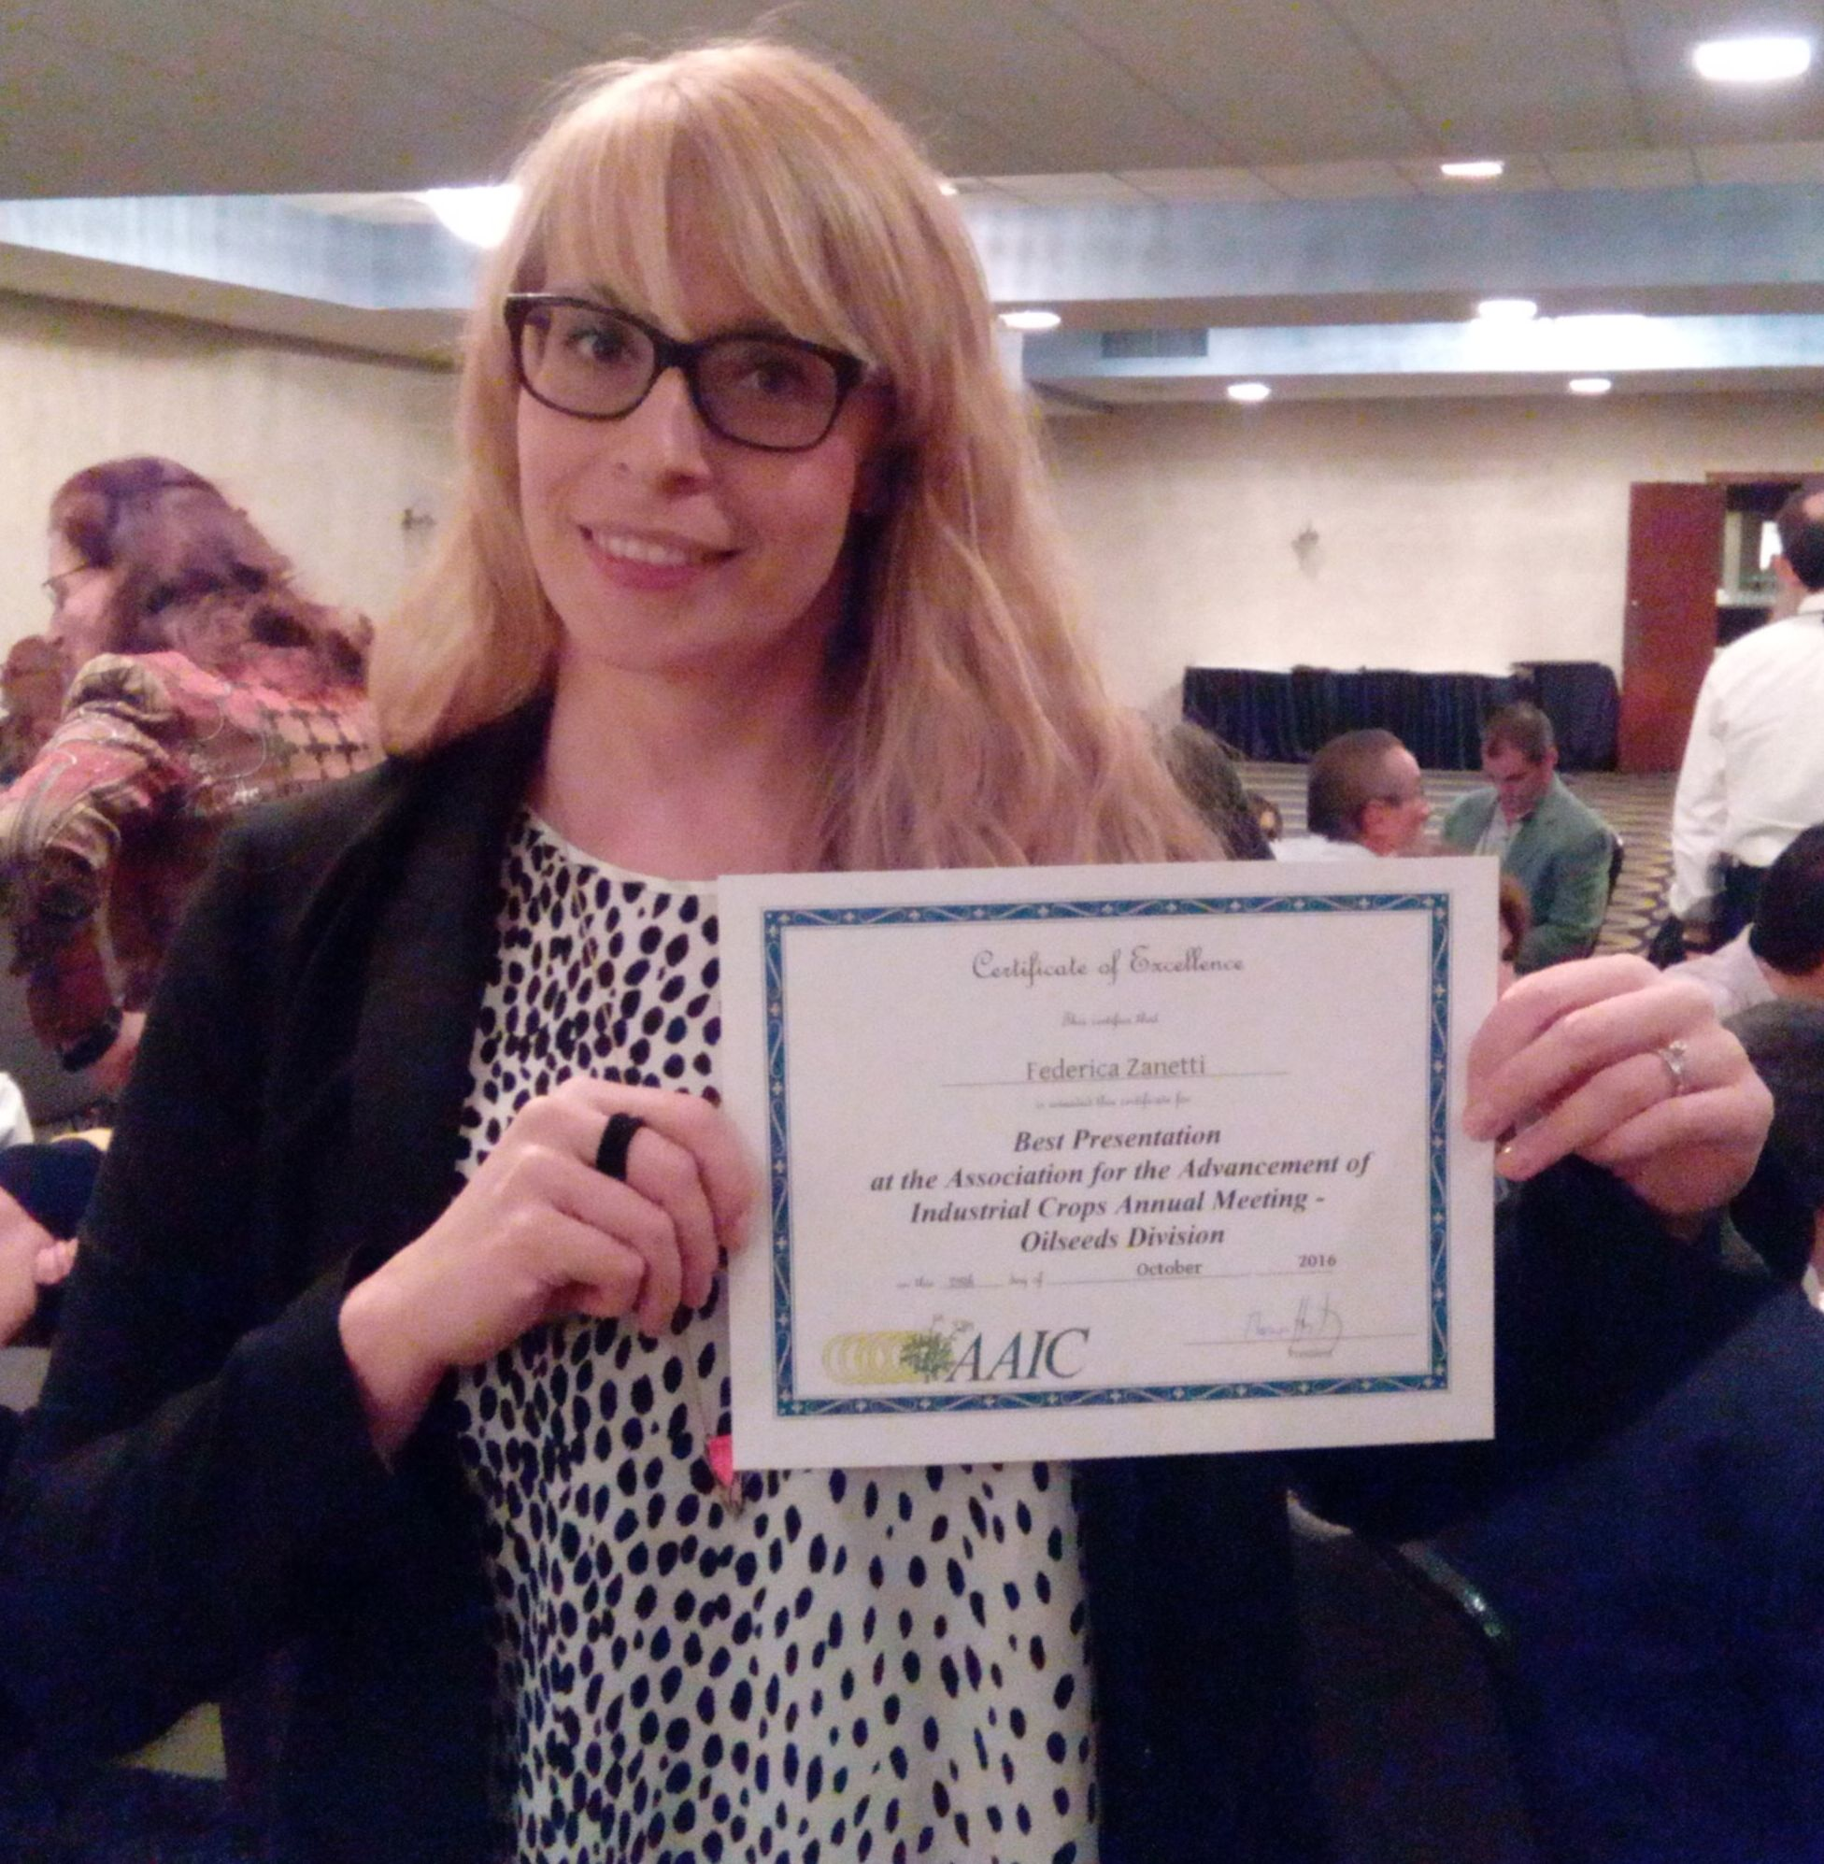
Born in Piove di Sacco (PD), Italy, on the 4th of July 1976.

AFFILIATION
Department of Agricultural Sciences, Alma Mater Studiorum
University of Bologna
Viale Fanin 44, 40127 Bologna (Italy)
Phone: +39 051 2096655
Email: federica.zanetti5@unibo.it

EDUCATION
2002-2005 PhD in Environmental Agronomy at University of Padua (Italy), defending a thesis entitled “Non-food Brassicaceae: evaluation of innovative cropping systems based on new oil crops”. Supervisor: Prof. Giuliano Mosca.
1996-2001 Master degree in Agricultural Sciences and Technology at University of Padua (Italy). Thesis entitled “Geostatistical approach in studying maize root system”. Supervisor: Prof. Giuliano Mosca
1998-1999 Erasmus fellowship for attending 9 months at the Wageningen University (The Netherlands) in the Dept. of International Marketing

ACADEMIC COURSES DURING AND AFTER THE PhD
2015 Introductive course to “LCA, Life Cycle Assessment”, Bologna (Italy). 2012 International course “Biorefining Training School 2012”, Wageningen (The Netherlands). 2006 Course “The rhizosphere: the roots of soil-plant interaction” organized by the Italian School of Agricultural Chemistry, Portoferraio (Italy). 2004 Internship at INNOVHUB – Experimental Station for Fats and Lipids in Milan (Italy), supervised by Dr. Paolo Bondioli. 2003 Course on “Crop Physiology” organized by the Italian Society for Agronomy in Catania (Italy)

ACADEMIC POSITIONS
2016 – present Assistant professor at Bologna University (Italy) in the Dept. of Agricultural Sciences. Academic discipline: AGR/02 Agronomy and Crop Science
2015-2016 Research fellow at Bologna University (Italy) in the Dept. of Agricultural Sciences within the EU project “COSMOS” (Camelina & crambe Oil crops as Sources for Medium-chain Oils for Specialty oleochemicals)
2012-2015 Research fellow at Bologna University (Italy) in the Dept. of Agricultural Sciences within the EU project “OPTIMA” (Optimization of Perennial Grasses for Biomass Production)
2010-2012 Research fellow at Padua University (Italy) in the Dept. in the Dept. of Agronomy, Food, Natural resources, Animals and Environment within the national project BIOSEA studying “Adaptation of bioenergy oil crop root system to contrasting agronomic management”
2006-2010 Post Doc position at Padua University (Italy) in the Dept. of Agronomy, Food, Natural resources, Animals and Environment studying “Root growth and nitrogen nutrition in relation to seed qualitative characteristics in soybean and rapeseed”

AWARDS
2017 FABBR
2016 AAIC Award for best “oral presentation” in the “Oilseed section”
2015 SIA (Italian Society for Agronomy) Award for “Support to young researcher”
1998 Fellowship from “Aldo Gini” Foundation to attend a period of study abroad

RESEARCH TOPICS
Since the very beginning the principal research topic was focused on non-food oilseed crops, mainly belonging to the Brassicaceae and Euphorbiaceae families (i.e., B. napus, B. carinata, B. juncea, Crambe abyssinica, Camelina sativa, Thlaspi arvense, Ricinus communis, etc). Researches cover different aspects of agronomy and crop physiology, deepening the knowledge on the responses of these species to abiotic stresses, but also trying to introduce promising new oilseed crops in typical farming systems, as well as to tailor for these novel species ad hoc agronomic management practices aiming at increasing their productive performances in term of both seed quality and quantity. Particular attention has been paid to the biosynthesis of monounsaturated fatty acids (erucic and eicosenoic) and polyunsaturated fatty acids (linoleic and α-linolenic acid) in response to temperature during flowering and seed ripening stages. Furthermore, also the compositional aspects of soybean seeds have been investigated, in particular the responses of secondary metabolites (i.s., isoflavone) to abiotic stress and also to different agronomic practices. In addition to non-food oilseed crops in the last years the research topics include also biomass and fiber crops, i.e. perennial grasses (i.e., switchgrass, miscanthus, giant reed) for advanced biofuel production or bio-composites. Research mainly focus on agronomic studies investing plant growth, i.e., establishment and abiotic stress tolerance, and agronomic management, i.e. innovative cropping systems, cutting system, in particular under marginal soil conditions.

PARTECIPATION TO NATIONAL/INTERNATIONAL RESEARCH PROJECTS
2019- present PRIN National Project ARGENTO (Agronomic and genetic improvement of camelina (Camelina sativa (L.) Crantz) for sustainable poultry feeding and healthy food products), Coordinator UNIBO (Prof. Monti)
2017-present EU H2020 project PANACEA (A thematic network to design the penetration PAth of Non-food Agricultural Crops into European Agriculture). Coordinator: CRES (Greece), WP leader: UNIBO (Prof. Monti)
2017-present EU H2020 project MAGIC (Marginal land for growing industrial crops: Turning a burden into an opportunity). Coordinator: CRES (Greece), WP leader: UNIBO (Prof. Monti)
2017-present EU H2020 project BECOOL (Brazil-EU Cooperation for Development of Advanced Lignocellulosic Biofuels). Coordinator: UNIBO (Prof. Monti)
2015-2019 EU H2020 project COSMOS (Camelina & crambe Oil crops as Sources for Medium-chain Oils for Specialty oleochemicals). Coordinator WUR (The Netherlands), Task le
2013-2015 EU FP7 project FIBRA (Fibre crops as a sustainable source of biobased material for industrial products in Europe and China). Coordinator: CRES (Greece), WP leader: UNIBO (Prof. Monti)
2013-2014 National project “Guayule Natural Rubber”, funded by ENI - VERSALIS. Coordinator: UNIBO
2012-2014 EU FP7 project OPTIMA (Optimization of Perennial Grasses for Biomass Production) Coordinator: UNICT (Italy), WP leader: UNIBO (Prof. Monti)
2010-2012 National project BIOSEA (Optimization of existing value chains with environmental and economic sustainability). Coordinator: UNIBO (Italy)
2006-2009 National project “BIOENERGY” (Demonstration of feasible value chains for biofuels and lignocellulosic biomass). Coordinator: CREA (Italy)
2005-2008 National project “NO-FOOD” (Development of new value-chain for non-food crops: bio-oils, fiber, bio-molecules). Coordinator: UNIUD (Italy)
2002-2004 National project TISEN (Innovative and sustainable technologies for production and transformation of bio-energy and non-food crops). Coordinator: UNIBO (Italy)

INTERNATIONAL COLLABORATION
Austria: J. Vollman (BOKU university Vienna). Brazil: L. Severino (Embrapa). Canada: J. Grushcow and D. Puttick (Linnaeus Plant Sciences), C. Eynck (Agriculture and Agri-Food Canada), J. Todd (OMAFRA). France: S. Palu (CIRAD, Montpellier), A. Merrien (TerresInnovia), J.L Dubois (Arkema), J.P. Despeghel (Monsanto), S. Marsac (Arvalis), J.D Faure (AgroParisTech, Versailles), H. North (INRA, Versailles). Germany: H. Kage and U. Bottcher (Christian-Albrechts University, Kiel). Greece: M. Christou and E. Alexopoulou (CRES). Israel: I. Nir (Kaiima). Portugal: A.L Fernando (FCT, University of Lisbon). Poland: M Stolarski and M. Serbia: A. Marjanovic Jeromela (IFVCNS). Spain: D. Curt (Madrid University), E. Martinez-Force (CSIC, Sevilla). The Netherlands: R. Van Loo (Wageningen UR). USA: M. Berti (North Dakota State University), R. Gesch and J. Johnson (USDA-ARS-NCSCRL), T. Isbell (USDA-ARS-NCAUR).

TEACHING EXPERIENCE
2019-2020 Course of Plant Biology (Mod. 2) in the BS degree of Ornamental Plants and Landscape Protection, University of Bologna (3 CFU)
2018-2019 Course of “Agronomy and biomass crops” in the International Master Low Carbon Technology and Chemistry, University of Bologna (2 CFU)
2007-2008 Course of “Non-food uses of oilseed crops” at the University of Padua (Italy) (2 CFU)
2006-2007 Course of “Non-food uses of oilcrops” at the University of Padua (Italy) (1 CFU)

Co- supervisor of graduate, undergraduate and PhD student thesis
3 PhD students, 25 MS students, 40 BS students.
Supervisor of graduate, undergraduate and PhD student thesis
Supervision of 3 BS students.

OTHER SCIENTIFIC PROFESSIONAL ASSIGNMENTS
2019-2020 President of the AAIC (Association for the Advancement of Industrial Crops), international scientific society

EDITORIAL BOARD MEMBER:
Industrial Crops and Products (guest editor), Journal of Elementology

REFEREE SERVICE
Peer-reviewer for: Industrial Crops and Products, Italian Journal of Agronomy, GCB Bioenergy, African Journal of Agricultural Research, European Journal of Agronomy, Agronomy, Field Crop Research, Agronomy for Sustainable Development, Bioenergy Research, Communications in Biometry and Crop Science, Advances in Plants and Agriculture Research, Turkish Journal of Agriculture and Forestry, Rivista Italiana Sostanze Grasse, Bio-based and Applied Economics, etc.

CONFERENCE ATTENDANCE
Participation to more than 30 national/international conferences. In 15 of them I presented orally my research (10 international events).

PUBLICATIONS
Scopus Author ID: 23011030000
ORCID CODE: 0000-0003-4729-2082
H-index: 11
Total number of citations: 406
Publications in the top 90th percentile: 18 out of 33 in the period 2008-2019

Top 5 relevant publications

2019 Zanetti F, Isbell TA, Gesch RW, Evamgelista RL, Alexopoulou E, Moser B, Monti A 2019. Turning a burden into an opportunity: Pennycress (Thlaspi arvense L.) a new oilseed crop for biofuel production. Biomass Bioenergy 130, 105354.

Zanetti F, Scordia D, Calcagno S, Acciai M, Grasso A, Cosentino SL, Monti A, 2019. Trade-off between harvest date and lignocellulosic crop choice for advanced biofuel production in the Mediterranean area. Industrial Crops and Products 138, 111439
Zanetti, F., Zegada Lizarazu, W., Lambertini, C., Monti, A., 2019. Salinity effects on germination, seedlings and full-grown plants of upland and lowland switchgrass cultivars. Biomass Bioenergy 120, 273-280.
2016 Böttcher U., Rampin E., Hartmann K., Zanetti F., Flenet F., Morison M., Kage H., 2016. A phenological model of winter oilseed rape according to the BBCH scale. Crop & Pasture Science, 67, 345-358.
2015 Monti A., Zanetti F., Scordia D., Testa G., Cosentino S.l., 2015. What to harvest when? Autumn, winter, annual and biennial harvesting of giant reed, miscanthus and switchgrass in northern and southern Mediterranean area. Industrial Crops and Products 75 part B, 129-134.

