PERSONAL INFORMATION | Arūnas Molis
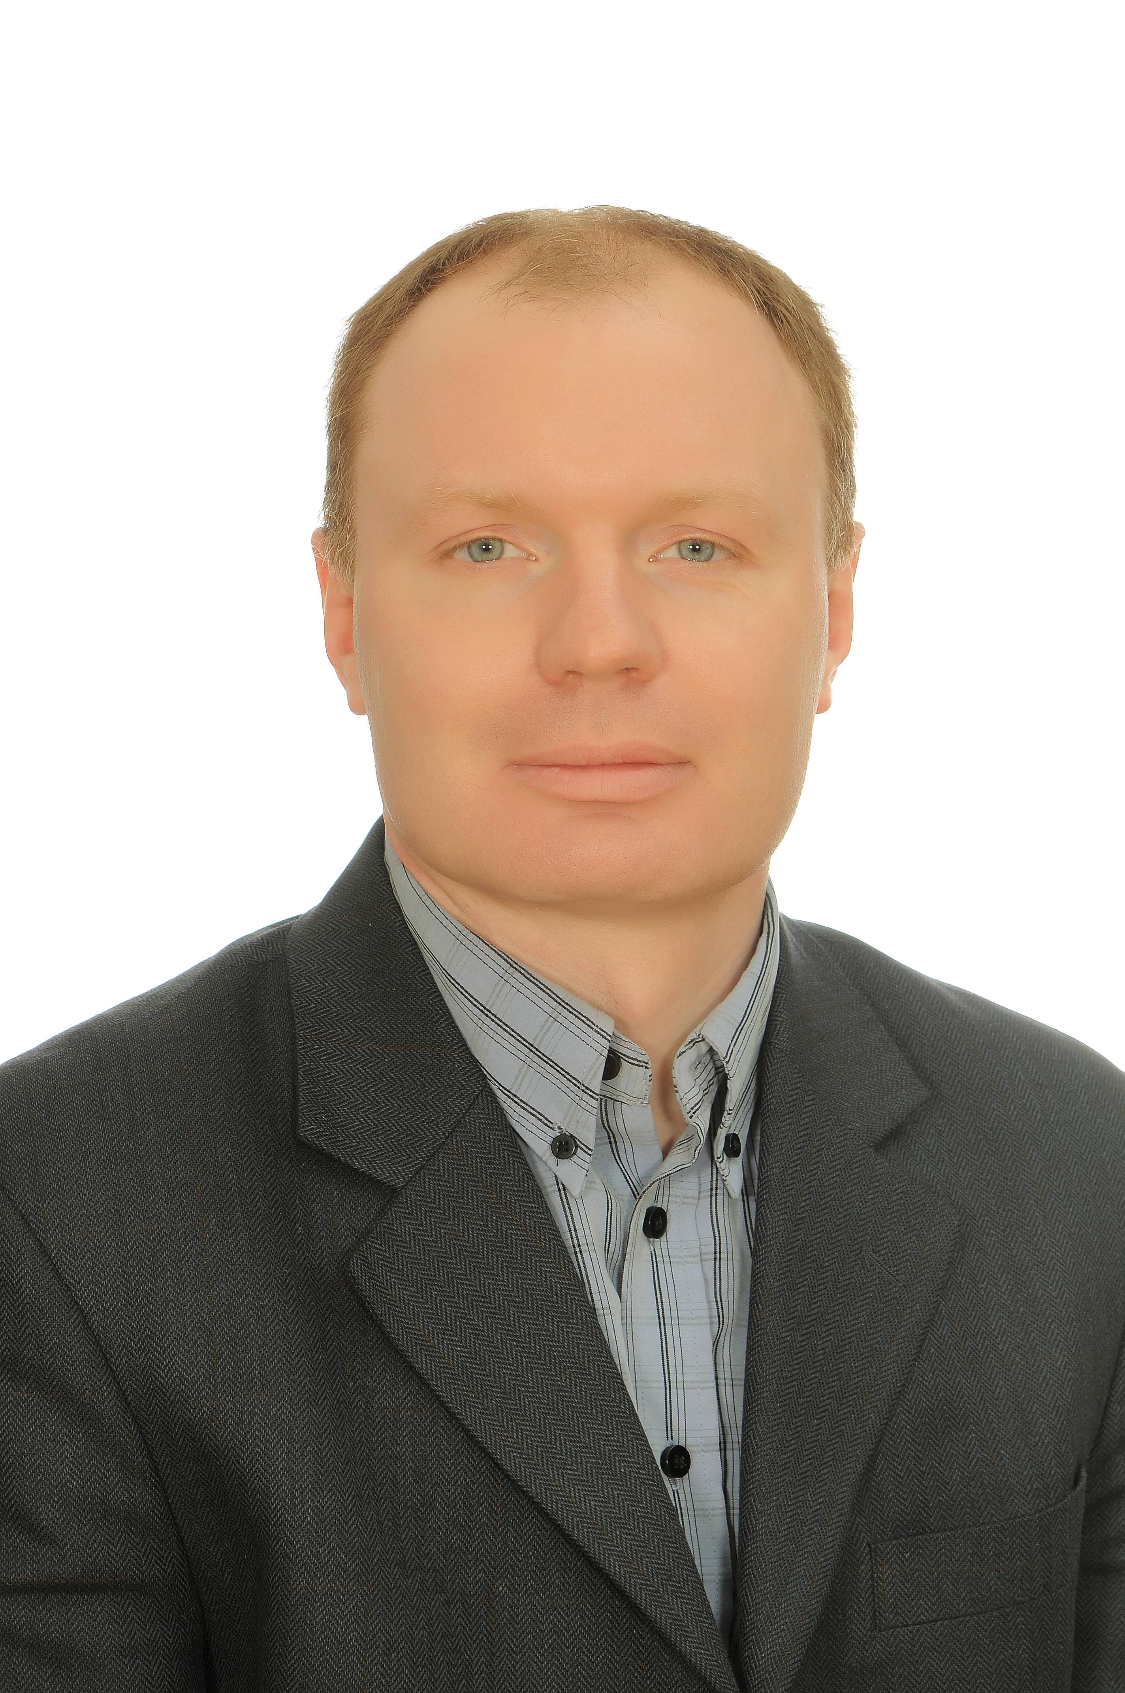 |   Kryžiokų str. 188B, 14270 Vilnius (Lithuania)

+37068545090

arunas.molis@gmail.com
 | Sex Male | Date of birth 25/05/1978 | Nationality Lithuanian

WORK EXPERIENCE
01/2019–present | Klaipeda LNG project executive, until June 2020 - Director of Klaipeda LNG Terminal, AB “Klaipedos nafta”
Vilnius, Klaipeda (Lithuania)
- management of Klaipeda LNG Terminal activities, implementation of Klaipeda long
term LNG supply project

10/2014–12/2018 |  | Adviser to the President of the Republic of Lithuania
 |  | Vilnius (Lithuania)
- advice to the President on energy and communication/transport affairs
- work with SOE, including “Lietuvos energija“, „Lietuvos geležinkeliai“, EPSO-G, „Klaipėdos nafta“, „Registrų centras“ etc.
- development and support to the President's initiatives at governmental and parliamentary levels
- preparation of material for President's meetings at the European and national levels
- contacts with private companies operating in energy and communications field, also national and European officials, domestic and international NGOs

01/2013–10/2014 |  | Head of Strategic analysis and research division
 |  | NATO Energy Security Centre of Excellence, Vilnius (Lithuania)
- development of Centre's vision and work priorities
- organization of exercises, including on critical energy infrastructure protection
- work on analytical and research papers
- leading internship program

02/2011–12/2012 |  | Head of Strategic analysis and research division, Deputy director
 |  | Energy Security Center by the Ministry of Foreign Affairs of Lithuania, Vilnius (Lithuania)
- preparation of analytical reports on energy security
- work on establishment of NATO ENSEC COE

09/2010–Present | Associate professor, adjunct professor, Professor
09/2010–Present | Faculty of Political science and diplomacy, Vytautas Magnus University, Kaunas (Lithuania)
09/2010–Present | - developing courses, lecturing security and international relations for local and Bologna University students (joint MIREES program)  - research at University's Energy security research center (until 2013)

05/2007–06/2010 | Academic, Head of Political and strategic studies department
05/2007–06/2010 | Baltic Defence College, Tartu (Estonia)
05/2007–06/2010 | - organization of Department's activities  - lecturing and research on defense and security issues  - representation of the College at the European security and defense college, organization of ESDC High Level Course Module in Tartu (Estonia)
08/2005–05/2007 |  | Head of Eastern countries monitoring division
 |  | Center for Strategic Studies, Vilnius (Lithuania)
- organization of Division's activities
- monitoring, analysis, research on energy, transport, Russia, Belarus, Moldova, Ukraine, South Caucasus, the EU, NATO

12/2002–08/2005 | Desk officer
12/2002–08/2005 | Ministry of National Defense, Vilnius (Lithuania)
12/2002–08/2005 | - defence planning

EDUCATION AND TRAINING

02/2020-06/2020 Istituto Italiano di Cultura in Lituania Vilnius, Italų kalba
2014–2016 | MA in International Business Law
2014–2016 | Faculty of Law, Vytautas Magnus University, Kaunas (Lithuania)
2013 | Lithuanian Military Academy, Vilnius (Lithuania)
2013 | - "Senior national security and defense course"

06/2009–11/2010 | Institute for European Politics, Berlin (Germany)
06/2009–11/2010 | - postdoc research on EU-Russia relations

2003–2008 | Phd in Political Science
2003–2008 | Institute of International relations and political science, Vilnius University, Vilnius (Lithuania)
2003–2008 | phd thesis on European security and defense policy future developments

01/2007–03/2007 | EU Institute for Security Studies, Paris (France)
01/2007–03/2007 | - Internship assisting researchers and writing phd paper on European defence

2006 | Austrian Institute for European Security Policy, Gumpoldskirchen (Austria)
2006 | - European security policy academy 2006

2004 | NATO School Oberammergau, Oberammergau (Germany)
2004 | - course on "NATO European security cooperation"

2001–2002 | MA in European Studies
2001–2002 | Hochschule Bremen, University of Applied Sciences, Bremen (Germany)

01/2000–02/2000 | Serbian language and history center "Azbukum", Novi Sad (Serbia)
1997–2001 | BA in Political Science
1997–2001 | Institute of International relations and political science, Vilnius University, Vilnius (Lithuania)
Mother tongue(s) | Lithuanian
Foreign language(s) | UNDERSTANDING |  | SPEAKING |  | WRITING
Foreign language(s) | Listening | Reading | Spoken interaction | Spoken production
English | C2 | C2 | C2 | C2 | C2
German | C1 | C1 | B2 | B2 | B2
Russian | C2 | C2 | C2 | C2 | C2
Serbian | B1 | B1 | A1 | A1 | A1
Italian | A1 | A1 | A1 | A1 | A1
 | Levels: A1 and A2: Basic user - B1 and B2: Independent user - C1 and C2: Proficient user

Communication skills | - communication skills gained through my experience at KN also as adviser to the President of Lithuania and professor at universities in Lithuania, Italy, Estonia, Germany, Czech Republic and South Korea  - contact skills with business, state officials, academics and military gained through my experience at KN, state and educational institutions, research centers and ministries
Organisational / managerial skills |  | - leadership (leading the project at KN, dealing with business, military, diplomats and politicians, CEOs of private and state owned enterprises)  - organizational skills (managing activities as director of the department or Head of the division at various institutions in Lithuania and Estonia)  - team-player skills gained as a member of management at KN, adviser to the President, also as a member of Supervisory board at NGO called "EDUCATIO: Institute for Education and Development"
Job-related skills |  | - knowledge of corporate governance system, political decision shaping and making, project management, reporting (reports written on academic and institutional purposes)

