CURRICULUM VITAE
ADEL ABDELALI
Research fellow at BiGeA

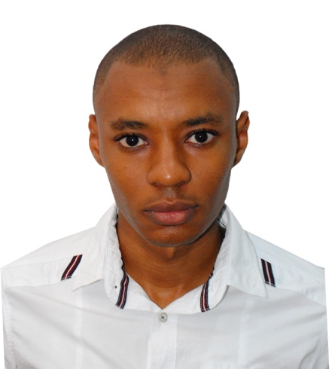

Address: Dipartimento di Scienze Biologiche, Geologiche e Ambientali
Piazza di Porta San Donato 1, Bologna
Tel (WhatsApp): (+213) 771 51 85 47
E-mail: adelabdelali5@gmail.com
ORCID: https://orcid.org/0000-0003-4598-9943

EDUCATION
2015-2020 | PhD in Hydrogeology at the University of Kasdi Merbah Ouargla, Ouargla, Algeria.  Thesis title: Application de la Géothermomètrie chimique à l'étude du système aquifère du Sahara septentrional (SASS) Algérien.  Supervisor: Prof. Imed Eddine Nezli
2013-2015 | Ms.c in Hydrology and Hydrogeology at the University of Science and Technology Houari Boumediène, Algiers, Algeria.  Thesis title: Application de la géothermomètrie chimique à quelque sources thermales de l’Est Algérien.  Supervisor: Prof. Ahmed Cherif Toubal
2010-2013 | Bs.c in Applied Geology at the University of Science and Technology Houari Boumediène, Algiers, Algeria.
2013 | English training, upper-intermediate level B2 at SBL school, Algiers, Algeria.

ACADEMIC POSITION
2021-2022 | Lecturer of Structural Analysis Practicals, Department of Geology, University of Kasdi Merbah Ouargla
2021-2022 | Lecturer of Cartography Practicals, Department of Geology, University of Kasdi Merbah Ouargla
2018-2019 | Lecturer of Cartography Practicals “Géologie de I'Algérie”, Department of Geology, University of Kasdi Merbah Ouargla
2016-2018 | Lecturer of Paleontology Practicals, Department of Geology, University of Kasdi Merbah Ouargla

RESEARCH INTERESTS
The focus of my research is water hydrogeochemistry. I am also interested in geothermometry and geochemistry of hydrothermal systems and groundwaters.
1) Geothermal energy exploration: Temperature estimation of geothermal reservoirs, and chemical processes occurring in geological formations explaining the distribution of major and trace elements in water, and identifying the thermodynamics and kinetics of reactions governing water-rock interaction.
2) A survey of Stable isotopes (δ²H, δ¹⁸O, δ³⁴S and 87Sr/86Sr) to study the meteoric cycle, salinity and contaminants origins, and transport in water.
Moreover, the aforementioned methods are also used to study the interactions between different end-members (groundwaters, hot springs, lakes, rivers and oceans).

My current project is the investigation of any traces of life in the Tanezrouft desert of Algeria. it is carried out by the characterization of evaporite samples taken from salt deposits. Analytical techniques include optical and electronic microscopy, confocal laser, and Raman spectroscopy.

PUBLICATIONS
Nezli, I.E., Kechiched, R., Mongelli, G., Abdelali, A., Nezli, A.R., Kouider, M.H., Benhamida, S.A., 2023. REE and Y distribution and speciation in fossil water: The northwestern African Continental Intercalaire aquifer, Algerian Sahara. Chem. Geol. 121894. https://doi.org/10.1016/j.chemgeo.2023.121894
Abdelali, A., Nezli, I.E., Kechiched, R., Attalah, S., Benhamida, S.A., Pang, Z., 2020. Geothermometry and geochemistry of groundwater in the Continental Intercalaire aquifer, southeastern Algeria: Insights from cations, silica and SO₄–H₂O isotope geothermometers. Applied Geochemistry 104492. https://doi.org/10.1016/j.apgeochem.2019.104492
Abdelali, A., Nezli, I.E., Benhamida, A.S., 2017. Geothermometry application to the Continental Intercalaire geothermal aquifer: a case study of Ouargla region. Energy Procedia 119, 264–269. https://doi.org/10.1016/j.egypro.2017.07.079

PRESENTED CONFERENCES
ORAL PRESENTATION ID: #34
- Abdelali, A., Nezli, I.E., Benhamida, A.S., 2017. Geothermometry application to the Continental Intercalaire geothermal aquifer: a case study of Ouargla region. The International Conference on Technologies and Materials for Renewable Energy, Environment and Sustainability. TMREES17-Spring Meeting. Beirut, Lebanon. April 21 to 24-2017.

POSTER PRESENTATION ID: 261
- Abdelali, A., Nezli, I.E., 2016. APPLICATION OF CHEMICAL GEOTHERMOMETERS TO THE CONTINENTAL INTERCALAIRE AQUIFER IN SOUTHEASTERN ALGERIA. International Conference on Integrated Environmental Management for Sustainable Development. Second Edition. Sousse, Tunisia. October 27 to 30-2016.

ATTENDED WORKSHOP
1st Europlanet Latin America Planetary Science Workshop-Connecting Earth with other Planets (online). 31.10-2023 to 03.11.2023, Buenos Aires, Argentina.

OTHER SKILLS
Languages  Arabic: fluent  French: good  English: very good | Software  Microsoft Office: Word, Excel, PowerPoint  Mapinfo, Surfer (G.I. S mapping), phreeqC, Diagramme, AqQa (Geochemical modeling)

